Rheno Rayhan F.D.P.

2I-TI / 2141720157 / 22

**Frequence Table & Histogram**

**Statistic Computation Week 3 Assignment**

Look at the data below! Make a frequency table and its Histogram!

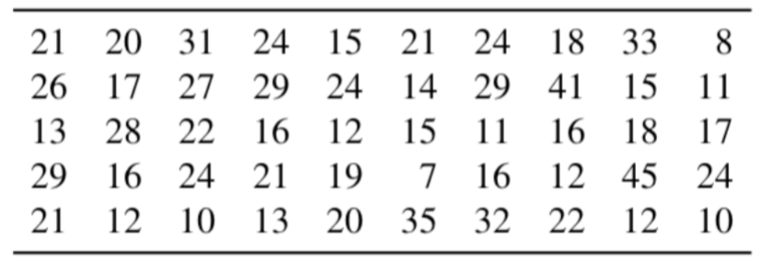

**Answer:**

Frequency Table



Histogram